**COVID 19 DATA EXPLORATION**

1. **Introduction:**

In this project, we use SQL server to explore global COVID 19 data following the instruction of [Alex The Analyst](https://www.youtube.com/@AlexTheAnalyst).

The dataset used in this project is the dataset used in [Data Analyst Portfolio Project | SQL Data Exploration | Project 1/4](https://www.youtube.com/watch?v=qfyynHBFOsM), which included 2 excel files [Covid Deaths](https://github.com/AlexTheAnalyst/PortfolioProjects/blob/main/CovidDeaths.xlsx) and [Covid Vaccinations](https://github.com/AlexTheAnalyst/PortfolioProjects/blob/main/CovidVaccinations.xlsx) contain covid data from January 28 2020 to April 30 2021.

The used dataset originally from [Coronavirus (COVID-19) Deaths - Our World in Data](https://ourworldindata.org/covid-deaths).

1. **Import Dataset into SQL Server:**

Use Import and Export Wizard in Microsoft SQL Server Management to import 2 excel files into SQL Server database.

* 1. Choose a Data Source. In this case, Microsoft Excel.

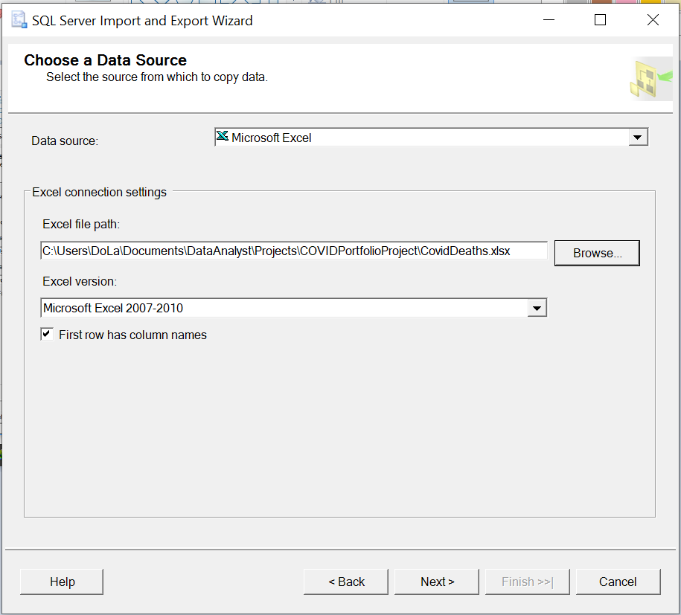

* 1. Choose a Destination, nn this case, Microsoft OLE DB Driver for SQL Server, and define Data Link Properties for the connection.

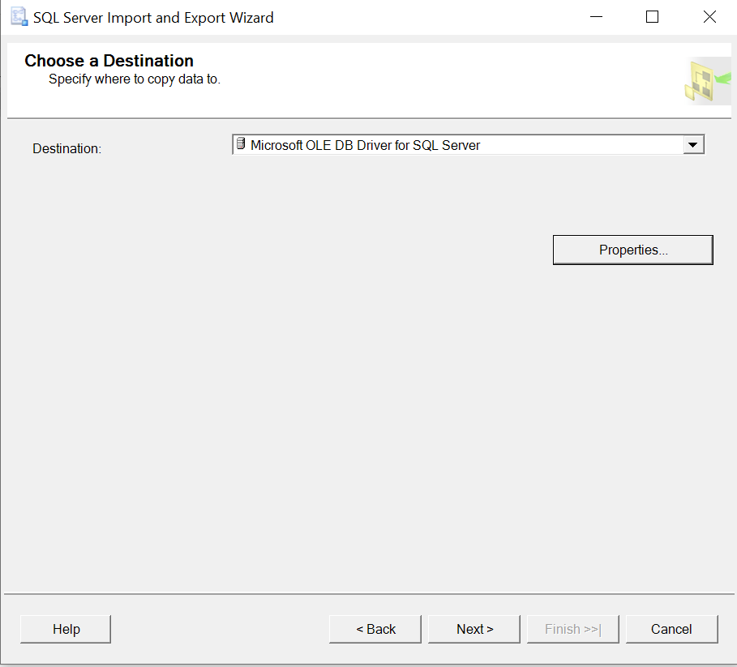

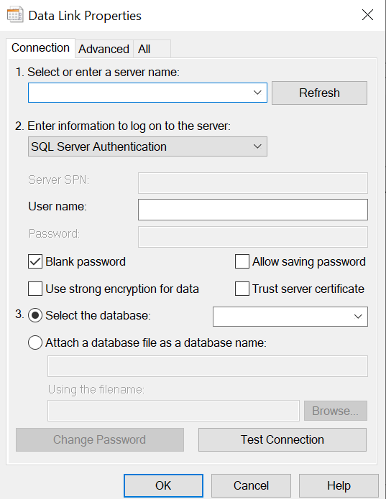

* 1. Choose Copy data from one or more tables or views.

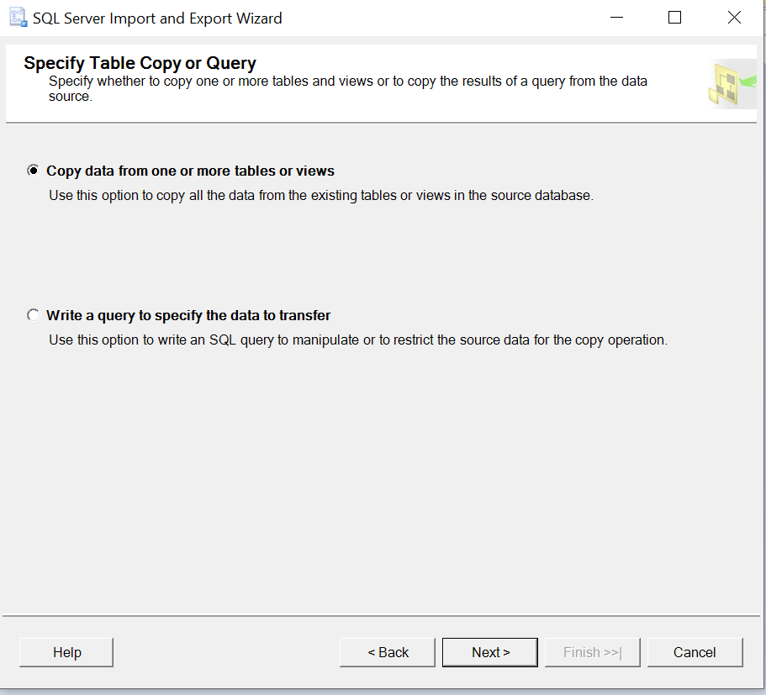

* 1. Select wanted sheet as Source Tables.

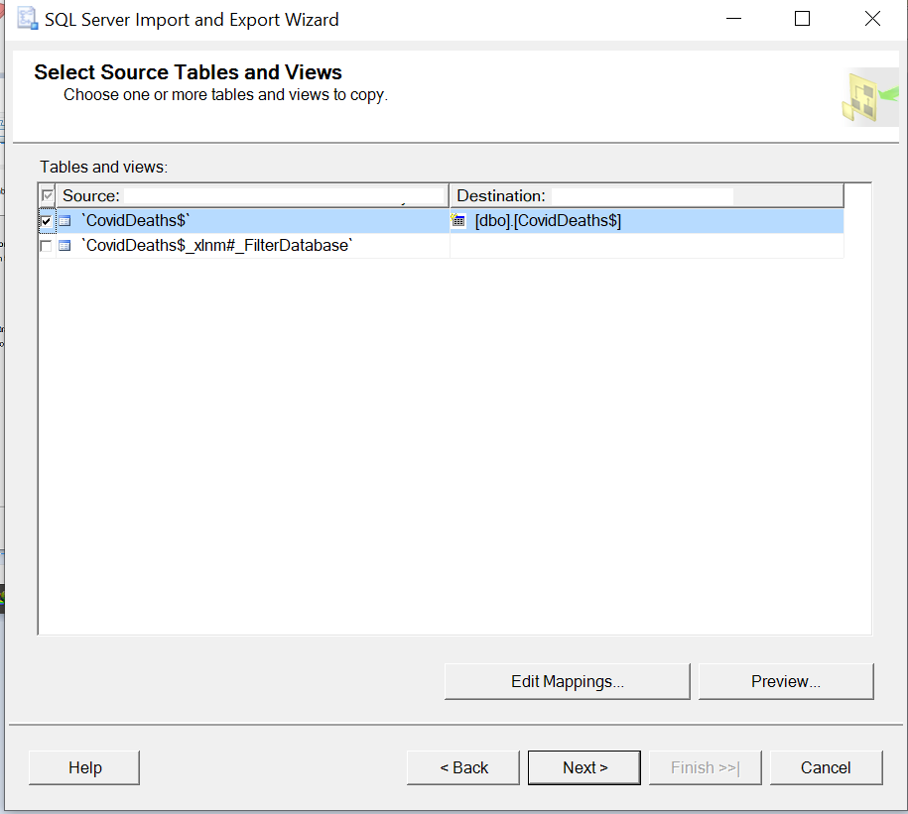

Remember to check and edit data type of each column in Edit Mappings.

* 1. Run the import process.

1. **Data Exploration:**
2. **Total Cases vs Total Deaths:**

Find the likelihood of dying if you contract covid in each country.

select location, date, total_cases, total_deaths, (total_deaths/total_cases)*100 as death_percentage

from PortfolioProject..CovidDeaths

where continent is not null

order by location, date;

1. **Total Cases vs Population:**

Find the percentage of population infected with covid in each country.

select location, date, population, total_cases, (total_cases/population)*100 as percent_population_infected

from PortfolioProject..CovidDeaths

where continent is not null

order by location, date;

1. **Countries with Highest Infection Rate compared to Population:**

Find countries with highest infection rate compared to population.

select location, population, max(total_cases) as highest_infection_count, max((total_cases/population))*100 as highest_percent_population_infected

from PortfolioProject..CovidDeaths

where continent is not null

group by location, population

order by highest_percent_population_infected desc;

1. **Countries with Highest Death Count per Population:**

Find countries with highest death count per population.

select location, max(total_deaths) as total_death_count

from PortfolioProject..CovidDeaths

where continent is not null

group by location

order by total_death_count desc;

1. **Contintents with the Highest Death Count per Population:**

Find contintents with the highest death count per population.

select continent, max(total_deaths) as total_death_count

from PortfolioProject..CovidDeaths

where continent is not null

group by continent

order by total_death_count desc;

1. **Global Death Numbers:**

Find total infected cases, total deaths, death percentage across the world.

select sum(new_cases) as total_cases, sum(new_deaths) as total_deaths, (sum(new_deaths)/sum(new_cases))*100 as death_percentage

from PortfolioProject..CovidDeaths

where continent is not null;

1. **Total Population vs Vaccinations:**

Find population that has recieved at least one covid vaccine.

select dea.continent, dea.location, dea.date, dea.population, vac.new_vaccinations,

sum(vac.new_vaccinations) over (partition by dea.location order by dea.location, dea.date) as rolling_people_vaccinated

from PortfolioProject..CovidDeaths dea join PortfolioProject..CovidVaccinations vac

on dea.location = vac.location and dea.date = vac.date

where dea.continent is not null

order by dea.location, dea.date;

1. **Using CTE to perform Calculation on Partition By:**

Find percentage of population that has recieved at least one covid vaccine with CTE.

with pop_vs_vac (continent, location, date, population, new_vaccinations, rolling_people_vaccinated)

as

(

select dea.continent, dea.location, dea.date, dea.population, vac.new_vaccinations,

sum(vac.new_vaccinations) over (partition by dea.location order by dea.location, dea.date) as rolling_people_vaccinated

from PortfolioProject..CovidDeaths dea join PortfolioProject..CovidVaccinations vac

on dea.location = vac.location and dea.date = vac.date

where dea.continent is not null

)

select *, (rolling_people_vaccinated/population)*100 as vaccinate_percentage

from pop_vs_vac

order by location, date;

1. **Using Temp Table to perform Calculation on Partition By:**

Find percentage of population that has recieved at least one covid vaccine with temp table.

drop table if exists #percent_population_vaccinated

create table #percent_population_vaccinated

(

continent nvarchar(255),

location nvarchar(255),

date datetime,

population numeric,

new_vaccinations numeric,

rolling_people_vaccinated numeric

)

insert into #percent_population_vaccinated

select dea.continent, dea.location, dea.date, dea.population, vac.new_vaccinations,

sum(vac.new_vaccinations) over (partition by dea.location order by dea.location, dea.date) as rolling_people_vaccinated

from PortfolioProject..CovidDeaths dea join PortfolioProject..CovidVaccinations vac

on dea.location = vac.location and dea.date = vac.date

where dea.continent is not null

select *, (rolling_people_vaccinated/population)*100 as vaccinate_percentage

from #percent_population_vaccinated

order by location, date;